Challenge: Ancient Encodings

# Challenge Description :

**Your initialization sequence requires loading various programs to gain the necessary knowledge and skills for your journey. Your first task is to learn the ancient encodings used by the aliens in their communication.**

# Context :

## Decode a string to get a flag and read the python file to find out how to reverse it.

# Flag :

* First Install the files and read the text file, the text file should contain a string that you will need to decode.
* Looking at the python script it came with we can identify that the original string was originally encoded in base64 and then turned into a hex dump.

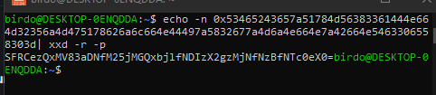

* Next thing to do would be to convert the hex dump string back to the base64 strings. Converting it With “**xxd**” with the right parameters gave me a base64 string, decoding this string will hopefully give me a flag.



* And it does the Flag is : **HTB{411_7h3_3nc0d1n9_423_h323_70_574y}**